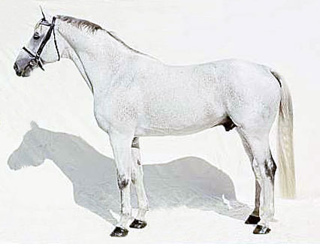
1
2
3
18

16
15
4
5
6
7
8
9
10
11

12
14
13
17
Label the points of the horse

1
2
3
4
5
6
7
8
9
10
11
12
13
14
15
16
17
18

