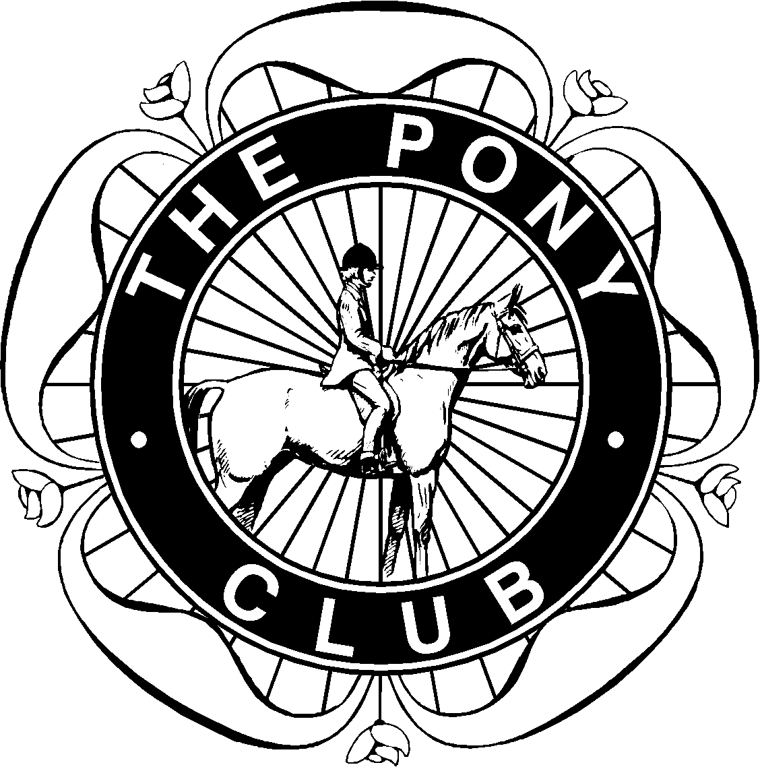

Morpeth Hunt
Pony Club
C test revision

Hi everyone

I’ve attached some questions to help you revise for your C test.
You’ll find all the answers in The Manual of Horsemanship.
If you have any queries please email me
Best wishes
Michelle
Keeping A Pony At Grass

- How often should you pick up droppings from the field and why?
- How many acres of grazing should each pony have if he is living out all year?
- Which other animals will keep the pasture free of worms?
- What is the ideal type of fencing for horses?
- What should you do if you think your pony has been poisoned?
- How can you make gates more secure?
- Why do ponies need shelter in the field?
- Name 4 poisonous plants
Field Care - Checking the field
Make a list of 6 things you would check before turning ponies out into a new field.

List the things that ponies can use for shelter in the field

What extra care does your pony need in the summer?

What extra care does your pony need in the winter?

Does their diet need to change in the summer and winter?
Explain why

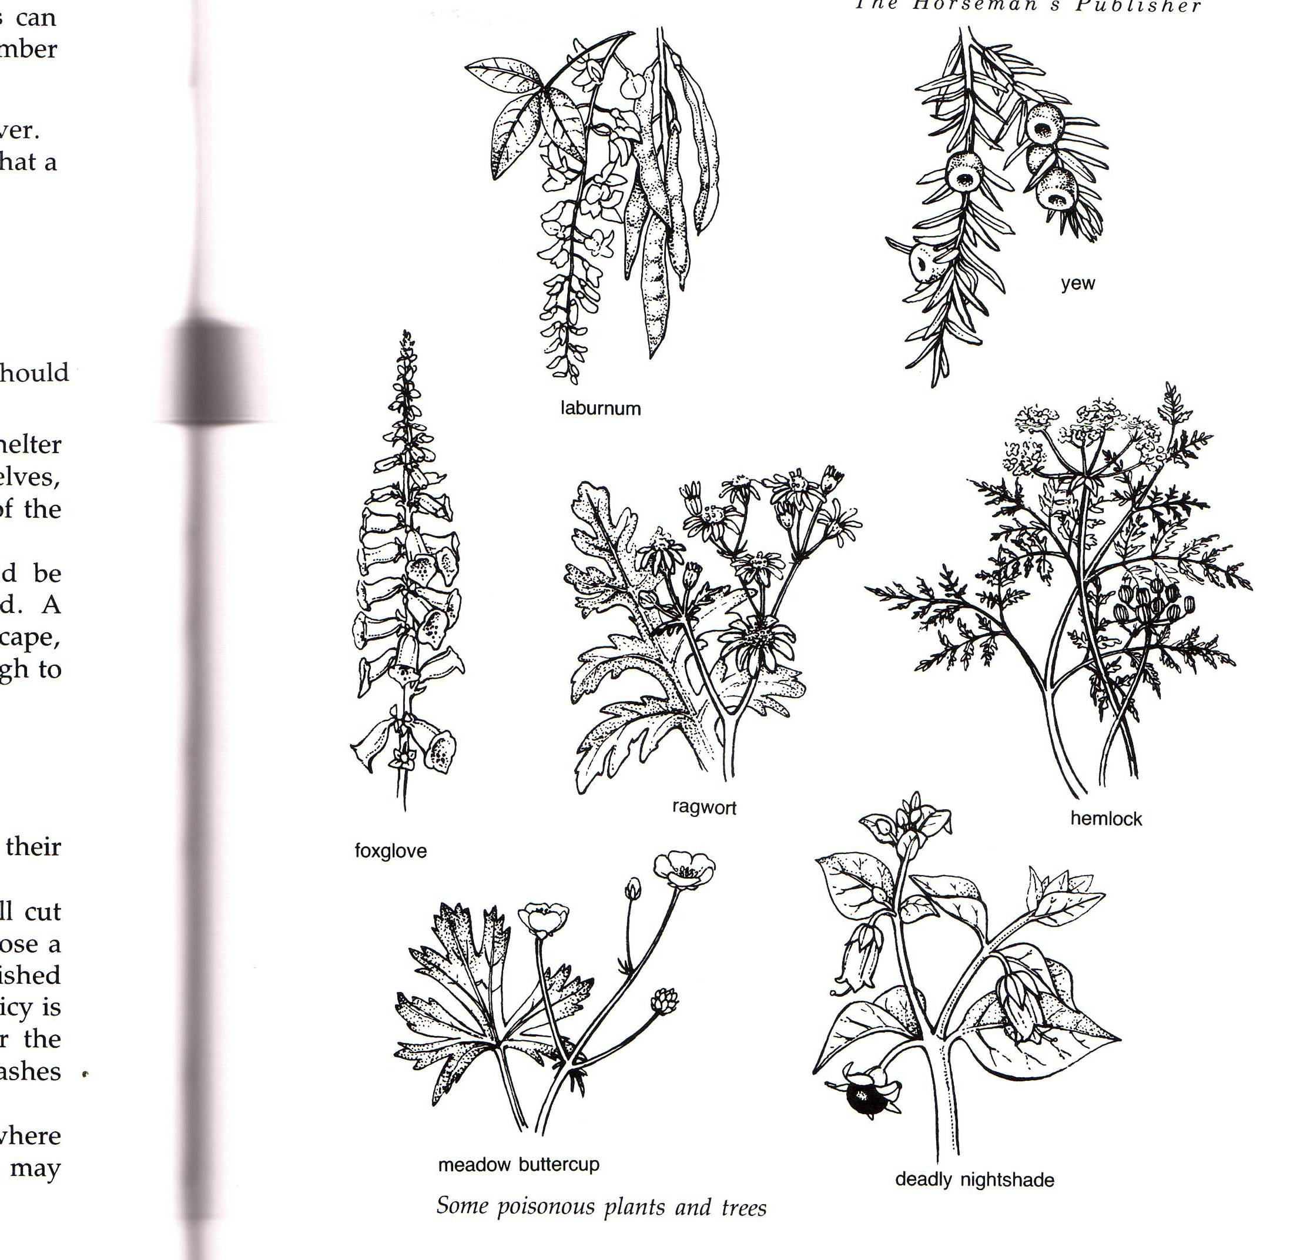
Poisonous plants

You need to know the following poisonous plants – find out what colour they are

Feeding Word Search

F E N Y G S N L D D G S V J C
E G U Q A A T E B R C T M M O
B A Y W R H E A A B M U H U N
G L B B J S W S O T J N G N C
E Y K E N R S O C H A Y K M E
B A H I H Q J O D T G D B A N
N H L N F F A H C A S B G I T
B T E E B R A G U S E I T Z R
D A A I S V T Q J K L M V E A
E X R E E B S E E D H A Y O T
W B M L G R T H D M F K L V E
S I R Q E H E W W S A C X P S
X P D U Z Y K W I Q D X X G N
N W A Q C Q O M F O A Q R T D
J F D F W X X Q S L F A S Z A

BARLEY
BRAN
CHAFF
COARSEMIX
CONCENTRATES
GRASS
HAY
HAYLAGE
LINSEED
MAIZE
MEADOWHAY
NUTS
OATS
SEEDHAY SUGARBEET

Feeding

List in the table below which feed is roughage and which is a concentrate

(hay, mix, nuts, sugar beet, oats, bran, chaff, barley, grass)

Roughage (fibre)

Concentrate

List the rules of feeding and explain why they are important

How do you work out how much food (hay / grass and hard feed) your pony should have per day?

How much does your pony weigh?

Name 4 different ways you can give water to your horses in the field

Label each of the grooming tools from the list below

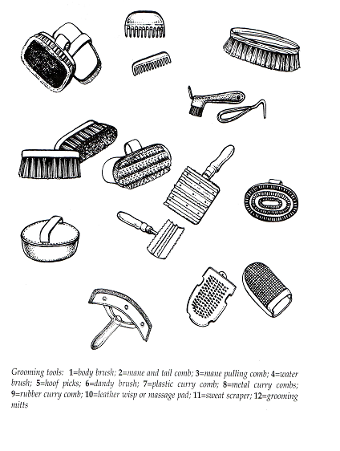

Why do we groom our pony? Tick the correct answers.

- To build up a good bond with them
- To help check for any injuries
- To remove dirt and grease from the coat
- To stop the tack rubbing
- To avoid tidying my bedroom
- To keep the coat clean and prevent disease
- To remove loose hair especially in the spring
- To make sure he won’t roll when he goes out in the field.
- So I don’t have to clean my tack so often

What brushes you would use on your grass kept pony-

What must you be careful of when grooming if your pony is living out without rugs?

Why do we bandage the horse’s tail? Give 3 reasons.

List the rules of bandaging a horses tail

Label the farriers tools below

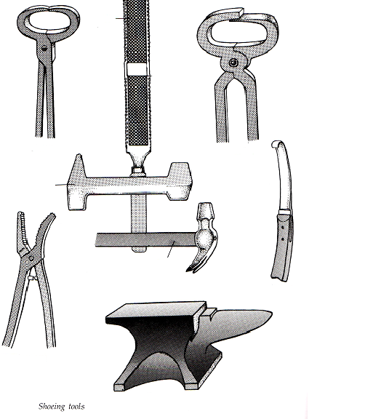

Give 4 reasons how you can you tell if a pony needs shoeing

Using the lists below, name the parts of the foot.
Toe, quarters, hoof wall, periople, coronet band
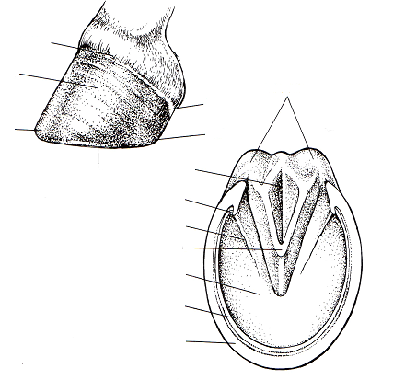
Bulbs of heel, sole, seat of corn, bars, wall, white line, frog

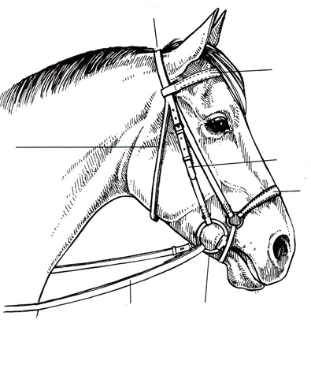
Name the parts of the Bridle

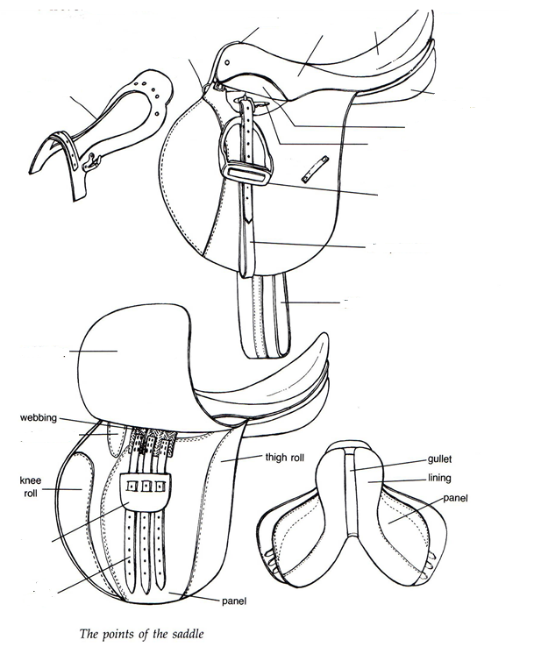
Name the parts of the saddle

The healthy horse
What are the signs of good health – use the picture below to show what they are
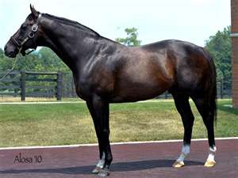
eg bright eyes

What are the signs of poor health - use the picture below to show what they are
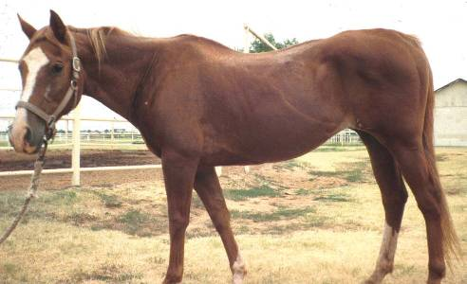
Eg dull staring coat

Wounds

If your pony cuts his leg in the field how will you treat it?

If deep or spurting with blood call the vet

Put the following in the correct order

If it is a minor wound……..

Treat with some antiseptic cream or spray
Keep the wound clean and check everyday for heat or infection
Clean the wound by gently cold hosing or bathing with warm salt water
Trim away any long hair from the edges of the wound
If necessary to help keep clean apply a dressing and bandage
Have someone hold your pony

You are out riding your pony and he goes lame – how can you tell?

For what reason would you call the vet?

When was your pony last vaccinated and why?

Travelling

Label the diagram bellow

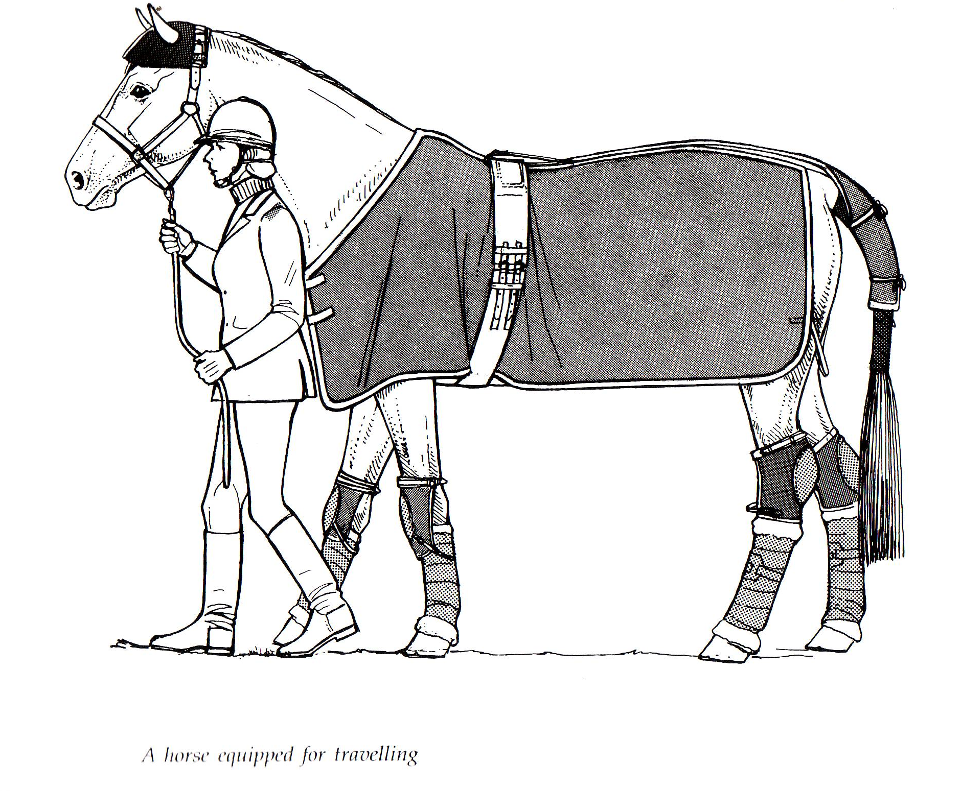

Gloves
Hat
Safe footwear

Poll guard
Travel rug
Roller
Tail guard
Tail bandage
Hock boots
Knee boots
Travel bandages
Fibergee or gamgee
Leather head collar

Points of the horse

On the picture below name as many points of the horse as you can

