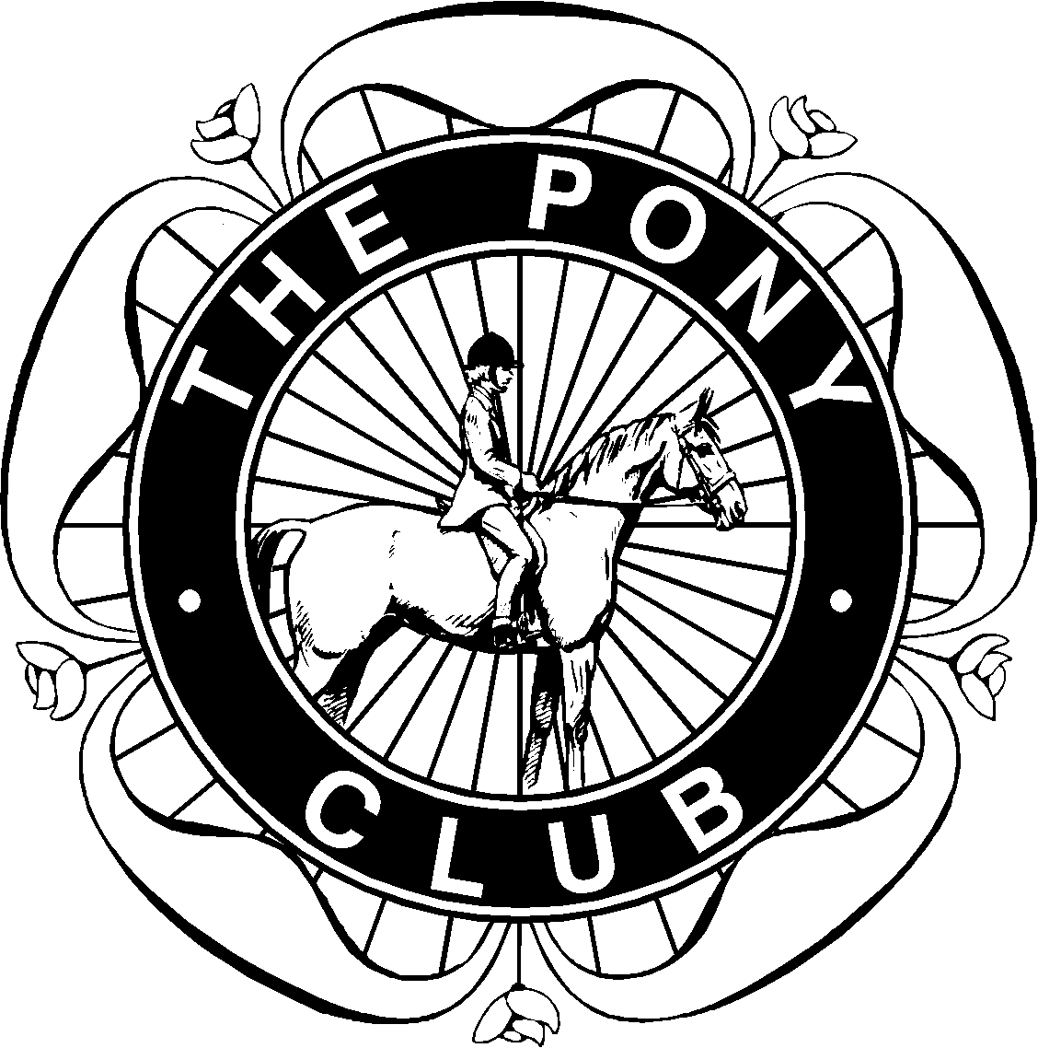

Morpeth Hunt
Pony Club
Flags of Equestrian Nations Achievement Badge

The aim of this badge is to have knowledge of eight equestrian nations, their Capitals and flags.
For each flag, say which country it’s from and what the capital city is. Then draw a line on the map showing where that country is.
If you have any queries please email me
Best wishes
Michelle
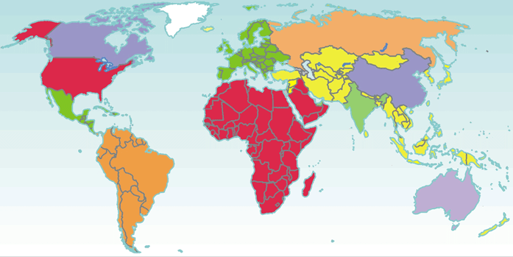
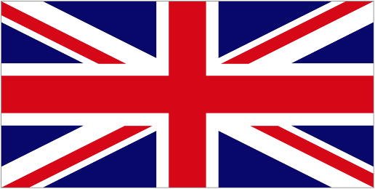
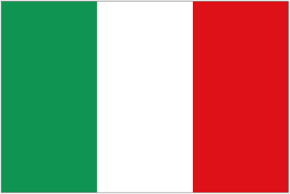
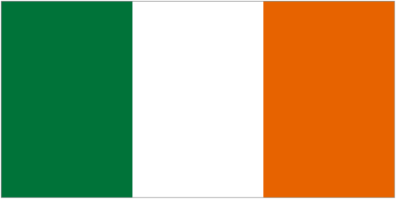
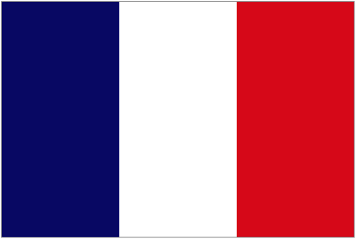
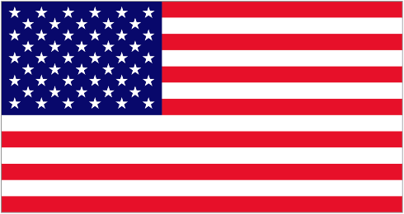
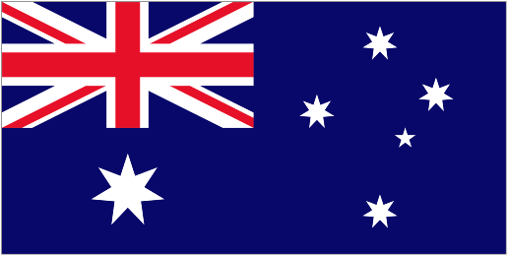
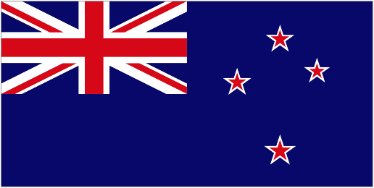
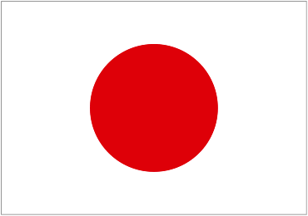
Country Capital City

_____________________ _______________________

_____________________ _______________________

_____________________ _______________________

_____________________ _______________________

_____________________ _______________________

_____________________ _______________________

_____________________ _______________________

_____________________ _______________________

⑤

⑥

⑦

⑧
①
②
⑤
⑥
⑦
⑧
④
③
①

②

③

④

