Tetrathlon rule changes for 2024

General notes all body protectors must comply to the 2018 Level 3 standard
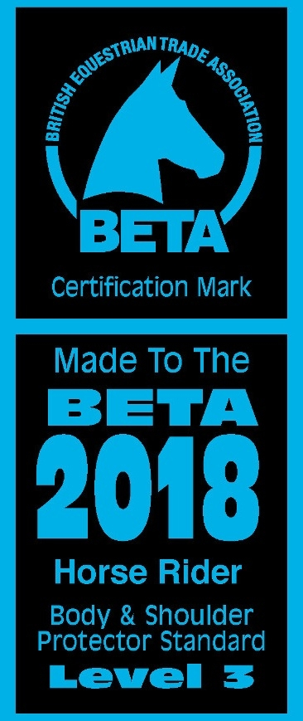
Swimming
Several swimming pools are now asking for a Swimming/Diving Competitive Start Award before swimmers use the Diving Blocks – this is to comply with the Insurance at some pools.
Therefore, all Members if they are using the diving Blocks will require this Award. It is not necessary if you just dive off the side.
Athletes who swim with a Swimming Club may already have this award, but others may not. We are arranging a session for our members to gain this certificate if required, details to follow. Those not achieving this award will have to dive off the side.
There has also been a new restriction on the depth of water that you can dive into –
1.35m if diving off blocks and 1.2m for diving off the edge of the pool. In a public pool, I am sure the depth will comply, I’ll check this with Willowburn for our area competition.

Rule Changes –
At the Championships the height of the Open fences to increase to 1.05m – this is not necessary at Area competitions.
A fall anywhere on the course will be regarded as a fall and therefor the rider must be checked in line with H & S.
A Horse resisting the rider anywhere on the course including at the gate and slip rail – results in retirement
Gate – timing to commence when the competitor first touches the gate and to end when the rope is in place. Failure to attempt to pass through, close or touch the gate until successful for a full period of 60 seconds results in retirement.
Sip Rail – Timing to commence upon the competitor dismounting and to stop when the slip rail has been replaced.
Jumping an obstacle in the wrong direction will result in mandatory retirement.

Dates for your Diary –
2nd January – riding phase training at Yafforth enter via Horse Events
7th January – Pendle Forest & Craven Tri enter via Horse Events
28th January - Zetland tri enter via Horse Events
27th & 28th April Bedale tetrathlon enter via Horse Events
20th & 21st July – area tetrathlon (entries will be made by me)

If you are entering any competitions, please let me know as I need to certify that you are competent at that level.
Any questions please let me know (DC@morpethhuntpc.co.uk)

Thanks
Michelle

